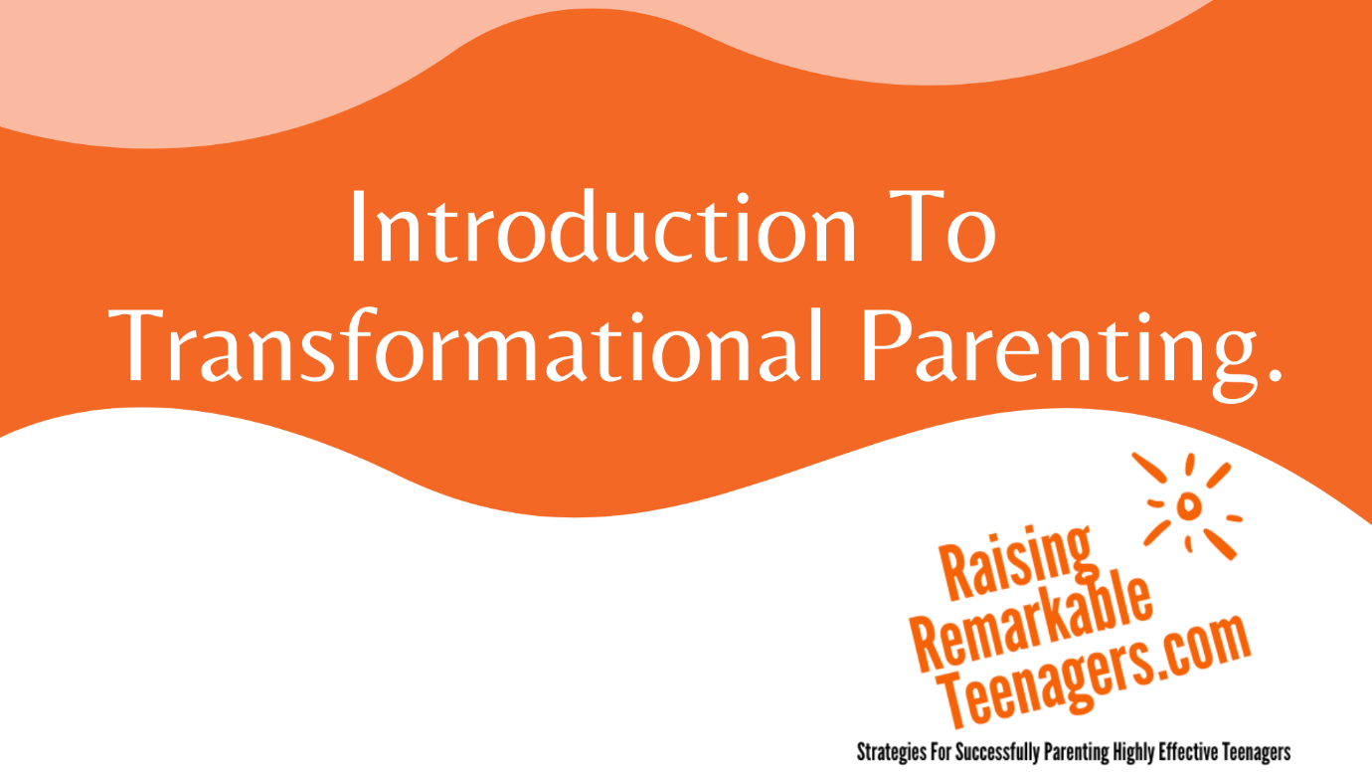
Raising Remarkable Teenagers Programs

With Psychologist, Researcher and Educator Angela Karanja

What is Transformational Parenting?

Transformational Parenting is…

YES | NO

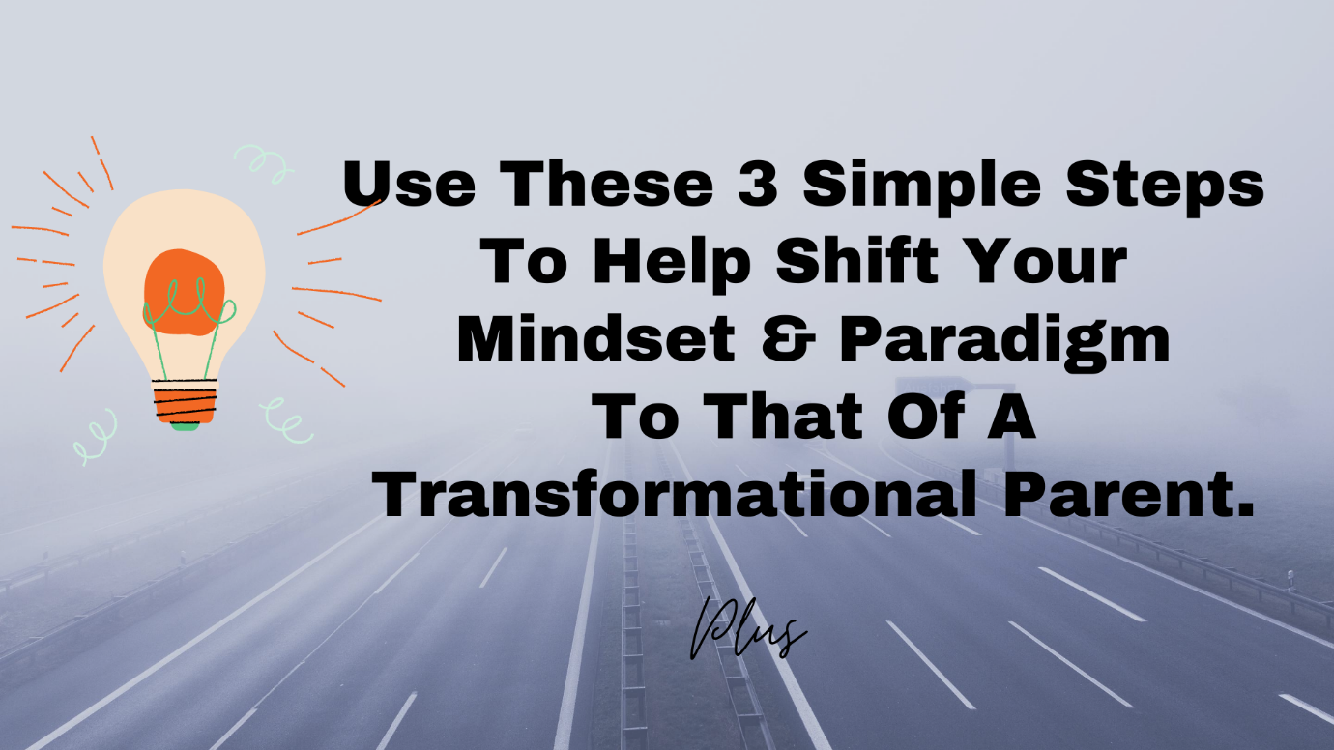

3 Steps To Shift Current Parenting Paradigm & Mindset

1

2

3
-
-
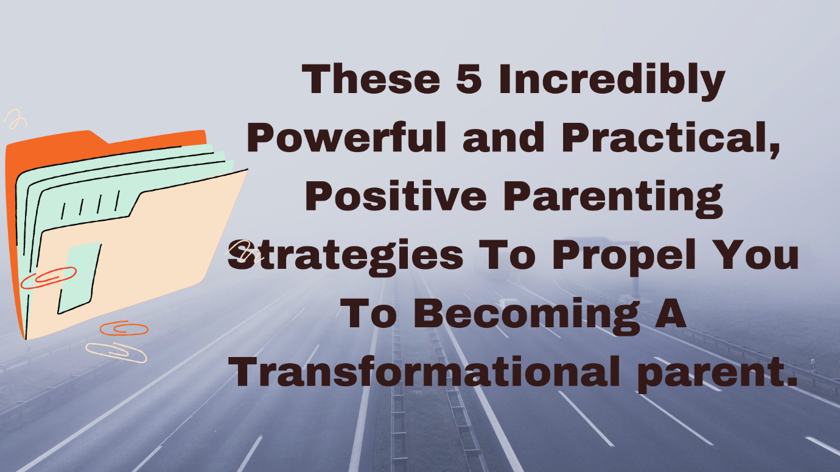

The 5Cs Essential Strategies of Transformational Parenting

1:

2:

3:

4:

5

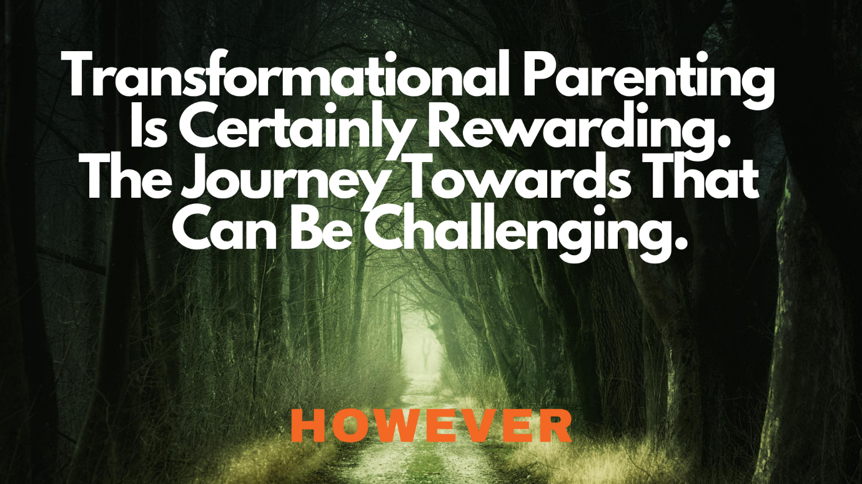

Think of the Rewards

Think of the Challenges

e.g. your current paradigm getting in the way
Paradigm (a set of beliefs and habits established over a long period of time)

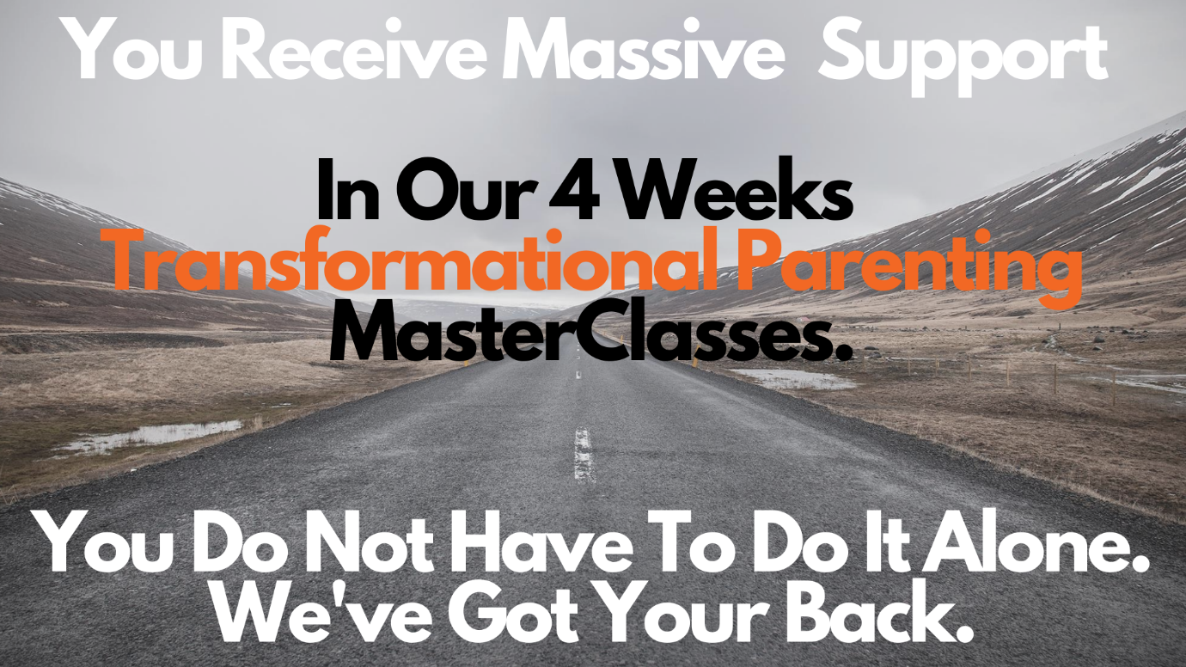

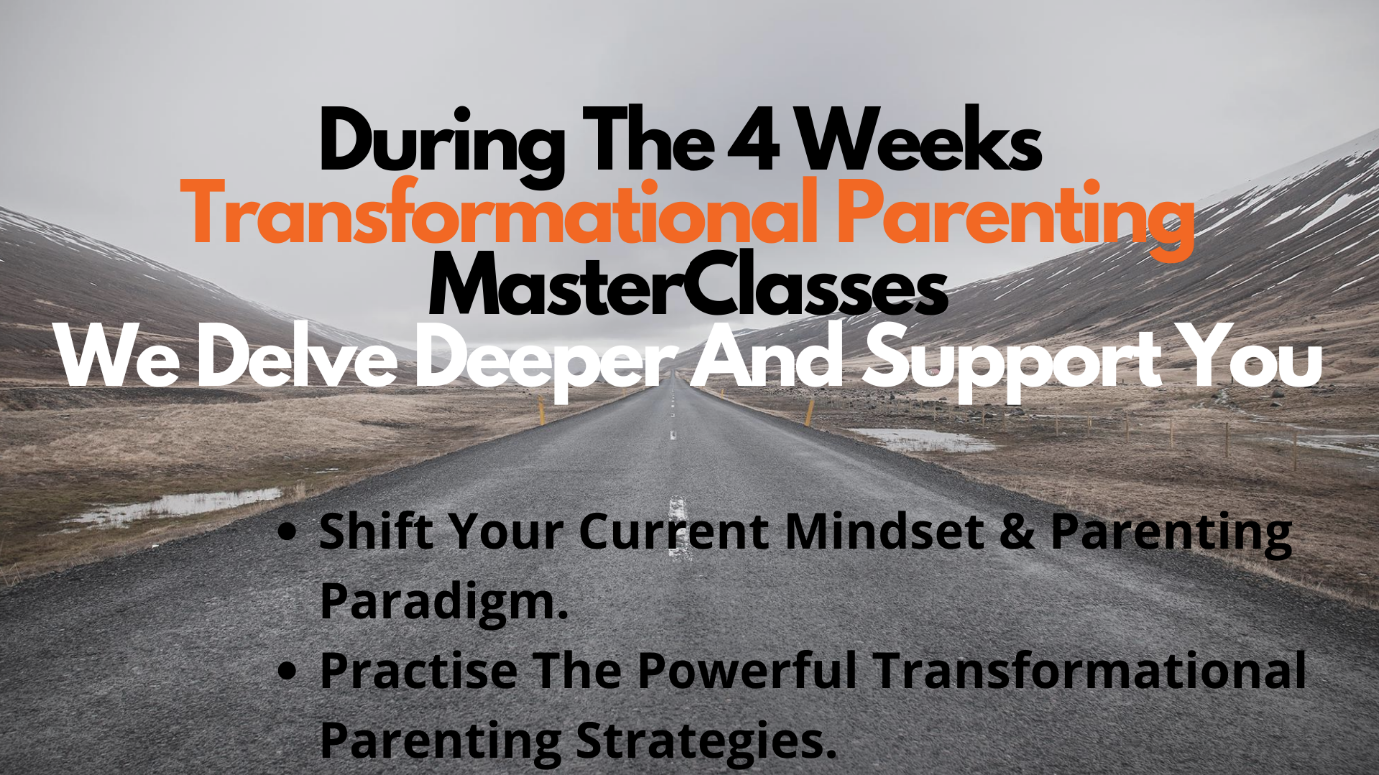

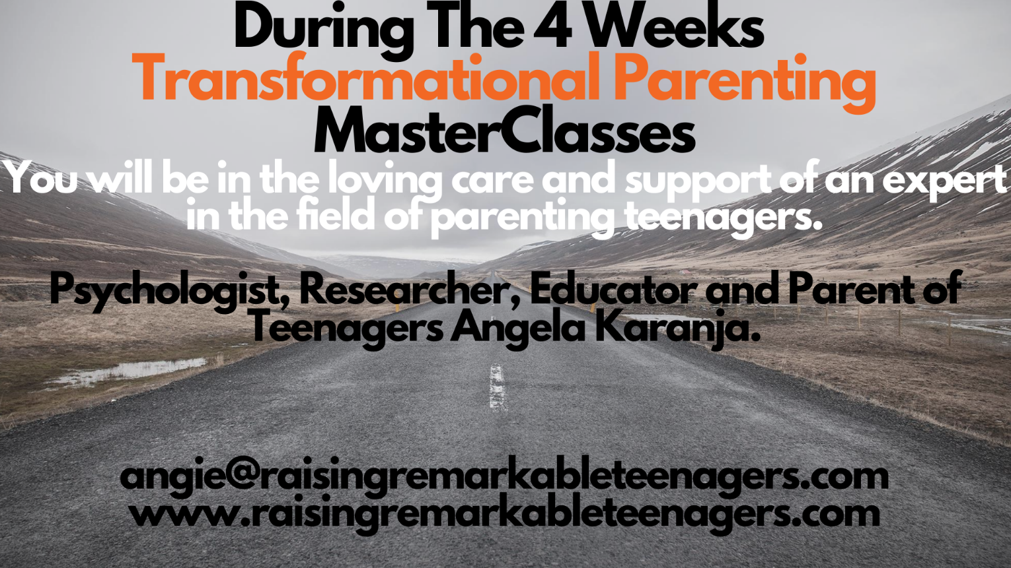

To Delve Deeper Consider The 4 Weeks Masterclasses.
When You Join You Receive These Bonuses

 | 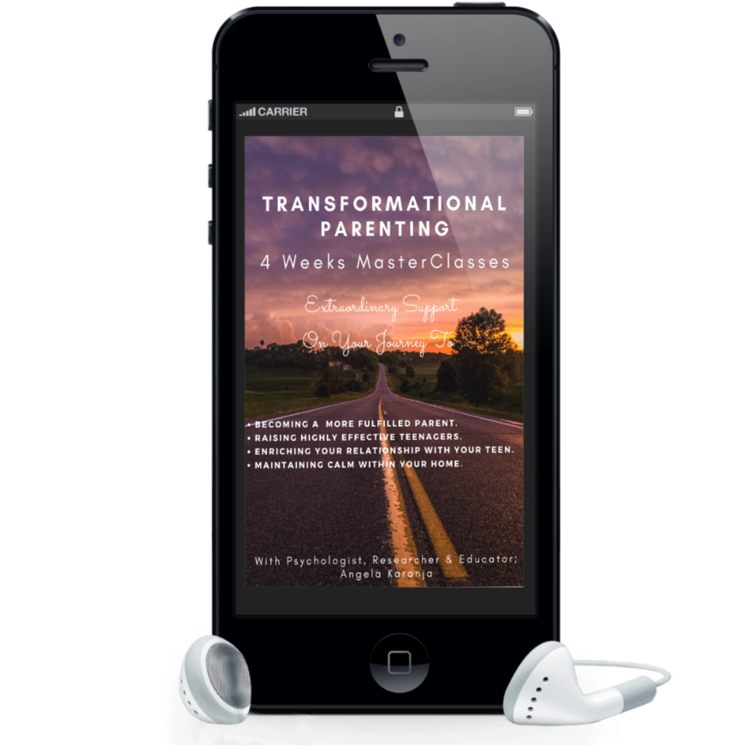
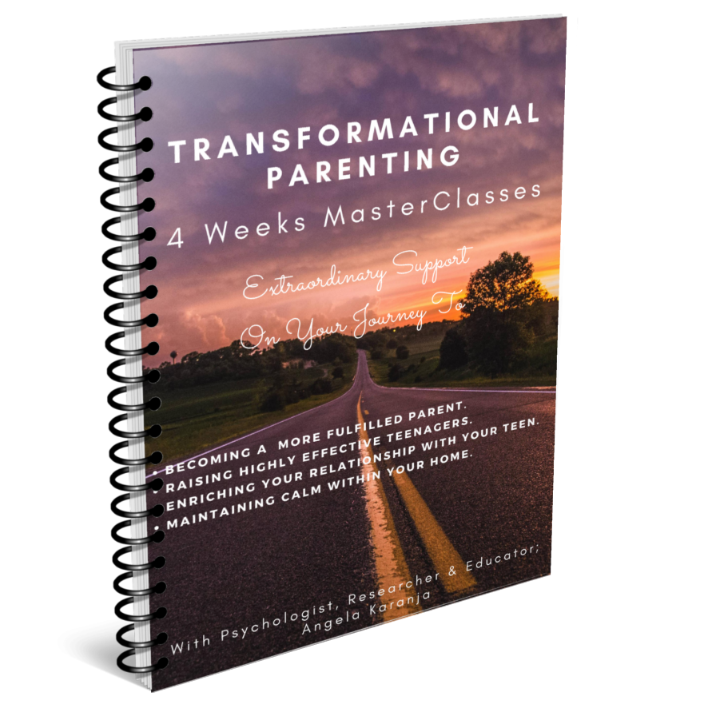 | 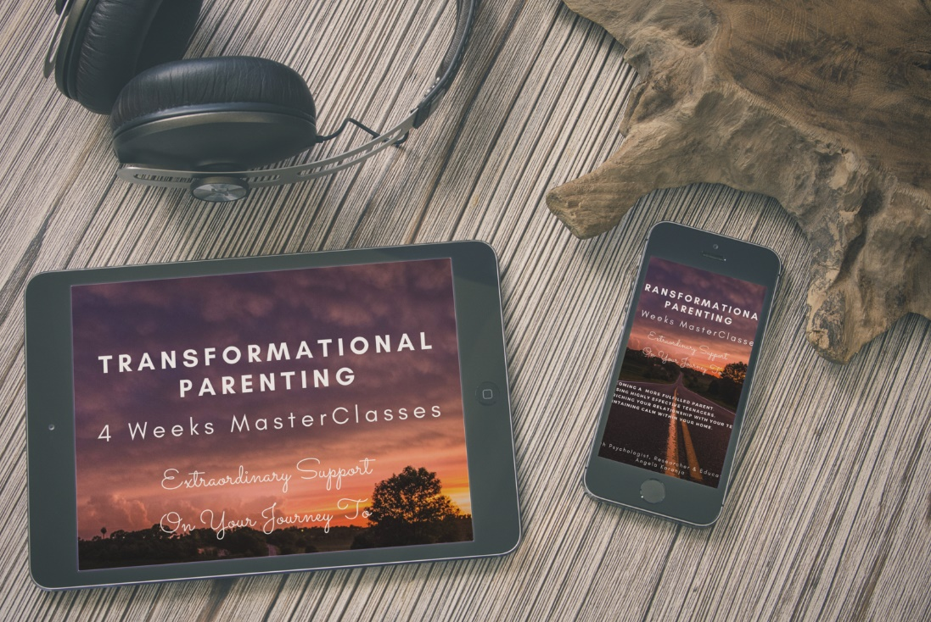

You Can Trust Our Expertise and Support
If in any doubt or experiencing any problems, contact
angie@raisingremarkableteenagers.com

